# CURRICULUM VITAE

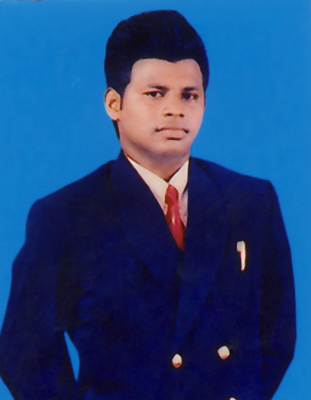

**SHRIYANTHA WICKRAMASEKERA**

Tel: 0777-915827 / 011-2728885

[shriyanthaa@gmail.com](mailto:shriyanthaa@gmail.com)

thilwick@gmail.com

**Post of: “Manager – Customer Services / Operations”**

**Present Salary & Expected Salary: Rs: 45,000/-**

**Personal Details:**

Name in Full : **Shriyantha Wickramasekera**

Gender : Male

Permanent Address : 37/A , Bellantara Road , Dehiwala

Telephone : **0777-915827 / 011-2728885**

Email : [shriyanthaa@gmail.com](mailto:shriyanthaa@gmail.com) / thilwick@gmail.com

Date of Birth : 27th April, 1973

School Attended : Science College – Mount Lavinia

**Core Competencies:**

* Team-player.
* Enthusiastic to learn new skills.
* Good problem solving and analytical skills.
* Strong ability to learn and adjust to new environments effectively.
* Ability to deliver good results consistently**.**

**[Next Page]**

**Education Qualifications:**

**Passed G.C.E [ O/L] Examination with 8 subjects.**

English - Credit

Commerce/Accounts - Credit

Sinhala - Credit

Social Studies - Credit

Religion - Credit

Health Science - Credit

Mathematics - Simple Pass

Science - Simple Pass

**Passed G.C.E [A/L] Examination with 4 subjects.**

Commerce / Finance - B

Accounts - C

Economics - C

Logic - C

**Professional Qualifications:**

* Obtained **“POST GRADUATE DIPLOMA”** in **“MANAGEMENT”** from **“NATIONAL INSTITUTE OF BUSINESS MANAGEMENT ”** [N I B M] COLOMBO
* Obtained **“MANAGEMENT DIPLOMA [Hons:]”** in “OPERATIONSMANAGEMENT ” specializing in **“CUSTOMER RELATIONS / PUBLIC RELATIONS &** **FRONT OFFICE OPERATIONS”** from **“ASIA LANKA INTERNATIONAL HOTEL SCHOOL”,** COLOMBO & NUGEGODA.

.

* The familiar with ***Microsoft office packages***

**[Next Page]**

**Worked Experienced & Duties:**

* Worked as an “ASSISTANT MANAGER – CUSTOMER SERVICES” at

**“SOUTH ASIAN TRAVELS LTD”,** G S A for **“KUWAIT AIRWAYS - SRI LANKA”**

from 5th August 1994 to 15th November:2000

**[Joined as a “MANAGEMENT TRAINEE” in 1993]**

**DUTIES:**

In-charge of the entire customer services team, front desk counter team, key client relations

attending to customer sales complaints and inquiries interacting with the in- bound marketing

& customer services team within respective region.

* Worked as a “MANAGER – CUSTOMER SERVICES ” at

**“HILTON INTERNATIONAL HOTELS - MALDIVES”** , from 12th Dec: 2000 to

20th December: 2003.

**DUTIES**:

Deputy head of the division & overlooked the entire customer services and front desk team

managing key client relations , attending to customer sales inquiries, staff training / recruitments

& interacting with the ***“Asia Pacific Region Marketing & Operations Division at Singapore”***

* Worked as a “MANAGER – CUSTOMER SERVICES” at

**“DOMINO’S INTERNATIONAL LANKA [PVT] LTD” - COLOMBO-3** , from

5th Feb: 2004 to 2nd January: 2006.

The Franchise Holder in Sri Lanka for the ….

**[DOMINO’S PIZZA INTERNATIONAL INC: USA]**

**DUTIES**:

Overlooked the entire customer services, customer complaints, key client relations, attending

to customer sales inquiries, public relations & interacting with the local & international client

base in the Indian sub continent.

Managed 15 Domino’s customer services centers within the Colombo Region. Overlooked 100 staff members in various categories.

* Worked as a “MANAGER – CUSTOMER SERVICES & OPERATIONS” at

**FORTE GRAND HOTELS MANAGEMENT CORPORATION - DUBAI”,** from

15th March: 2006 to 25th March:2008.

**DUTIES:**

Overlooked the entire customer services, managed the public relations & key client relations

attending to the customer sales complaints & inquiries interacting with the regional marketing

and operations division in the middle east sector.

**[Next Page]**

* **Present Employment:**

Presently working as a “MANAGER - CUST: SERVICES: & OPERATIONS” at

**“DATUM BARATH HOTELS & MANAGEMENT SERVICES[PVT] LTD”-** COLOMBO ,

since, 8th June: 2008 to-date .

Member of **“DATUM BARATH GROUP INDIA LTD.”**

**DUTIES:**

Overlooking the entire customer services, key client relations, managing the public relations

attending to customer sales inquiries, staff training , recruitments, managing the workflow within

the respective divisions, interacting with the international client base in overseas & corporate

sector officials in the two subsidiaries of the Datum Barath Group Country office Sri Lanka.

**Extra Activities[Sports]**

RUGGER: Member of the college Rugger team and had represented inter- school & national

tournaments locally & overseas.

Represented CH&FC [Kabs] 1988/89 at Rugby.

Member of the college Swimming and Life saving team and affiliated member

of the Royal Life Saving Society - New Zealand.

Member of the Mount – Lavinia Surf Club.

SWIMMING:

**DATE: 8th April:2015**

**SHRIYANTHA WICKRAMASEKERA**